**The PMMS hardware installation guide**

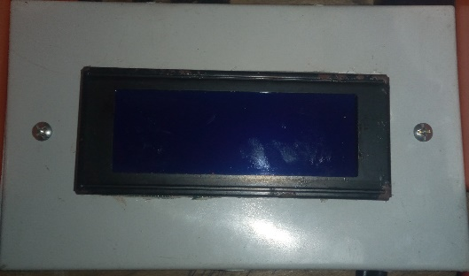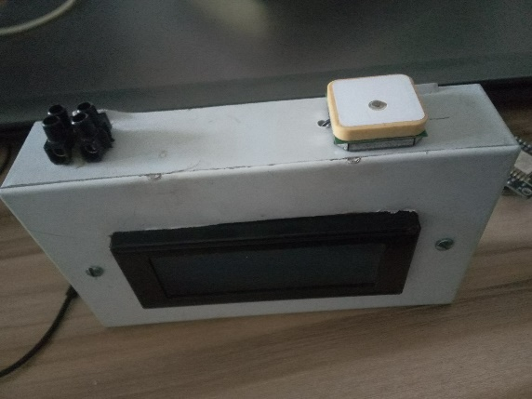

The PMMS is designed to monitor and manage power supply either from an industrial point or domestic point.

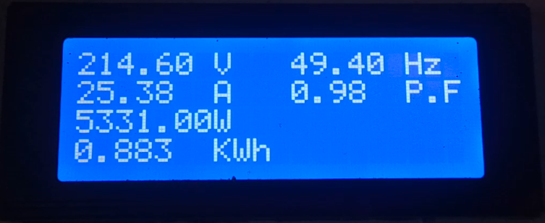

**Hardware used**

See Hardware Documentation for details

**Software**

* Arduino IDE

**Languages**

* C++
* C
* HTML
* CSS
* python

**Arduino IDE for ESP8266 WIFI chip**

This project makes use of the Arduino environment to support the ESP8266 chip.

The Arduino IDE allows you to write sketches using the familiar Arduino libraries and functions which can run on the ESP8266 wifi microcontroller.

ESP8266 Arduino core comes with libraries to communicate over WiFi using TCP and UDP, set up HTTP, mDNS, SSDP, and DNS servers, do OTA updates, use a file system in flash memory, and work with SD cards, servos, SPI and I2C peripherals.

**Installing with Boards Manager**

Starting with Arduino version 1.6.4, Arduino allows the installation of third-party platform packages using Boards Manager. There are packages available for Windows, Mac OS, and Linux (32 and 64 bit).

* 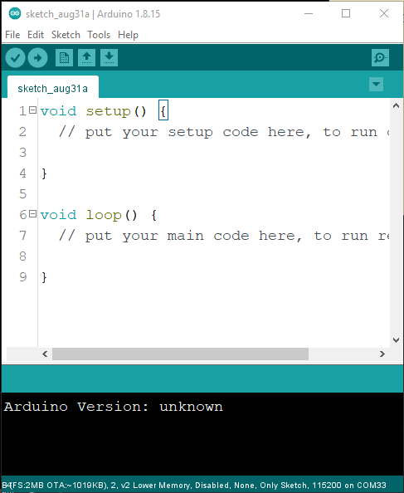Install the Arduino IDE at the 1.8.9 level or later. The current version is on the Arduino website (<https://www.arduino.cc>).
* Start Arduino and open the Preferences window (this is for window os).
* 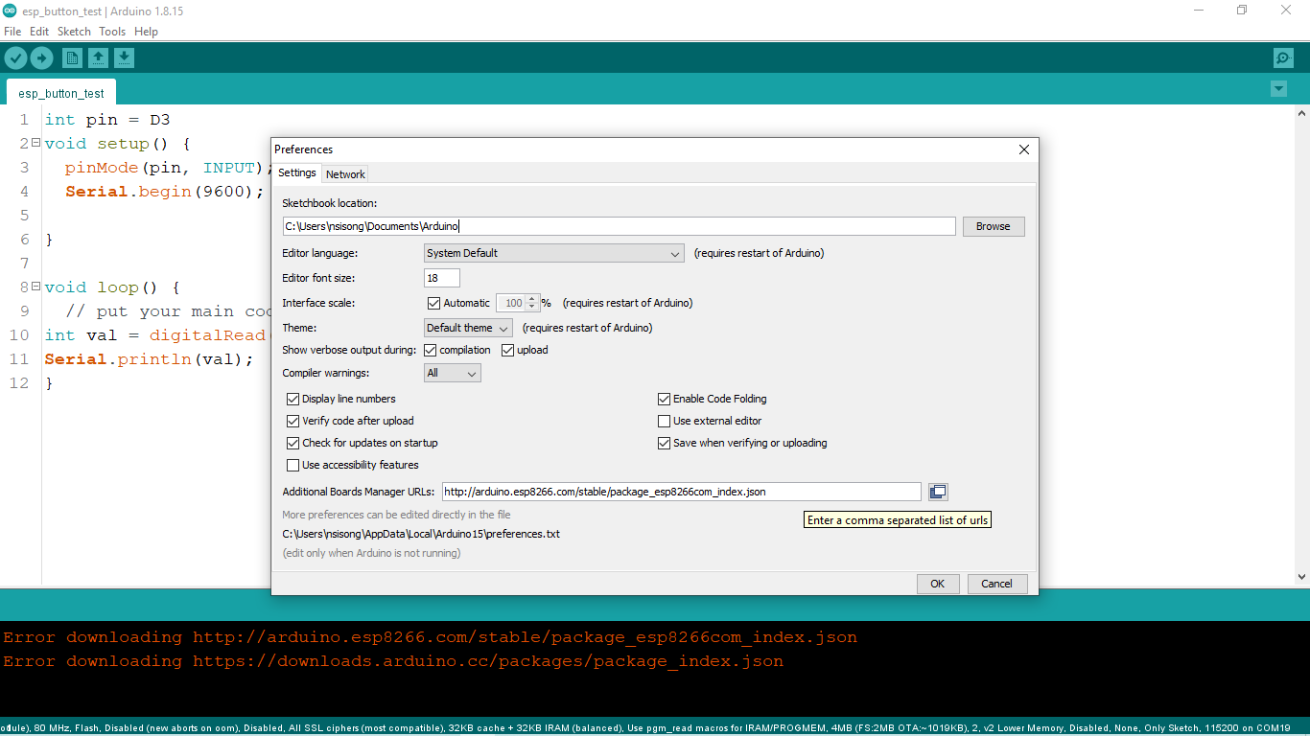Got to *File>Preferences>Additional Boards Manager URLs* field of the Arduino IDE. Enter this in the field https://arduino.esp8266.com/stable/package_esp8266com_index.json   
  into the You can add multiple URLs, separating them with commas.
* Click OK and exit.
* 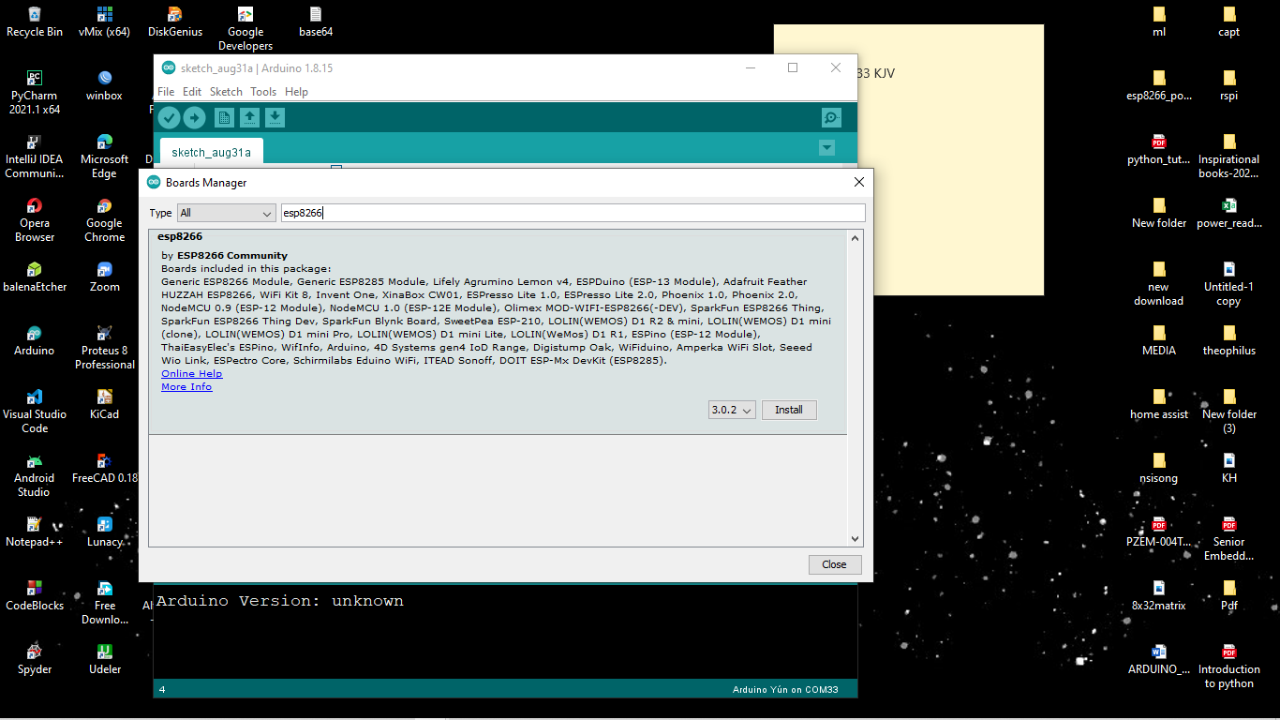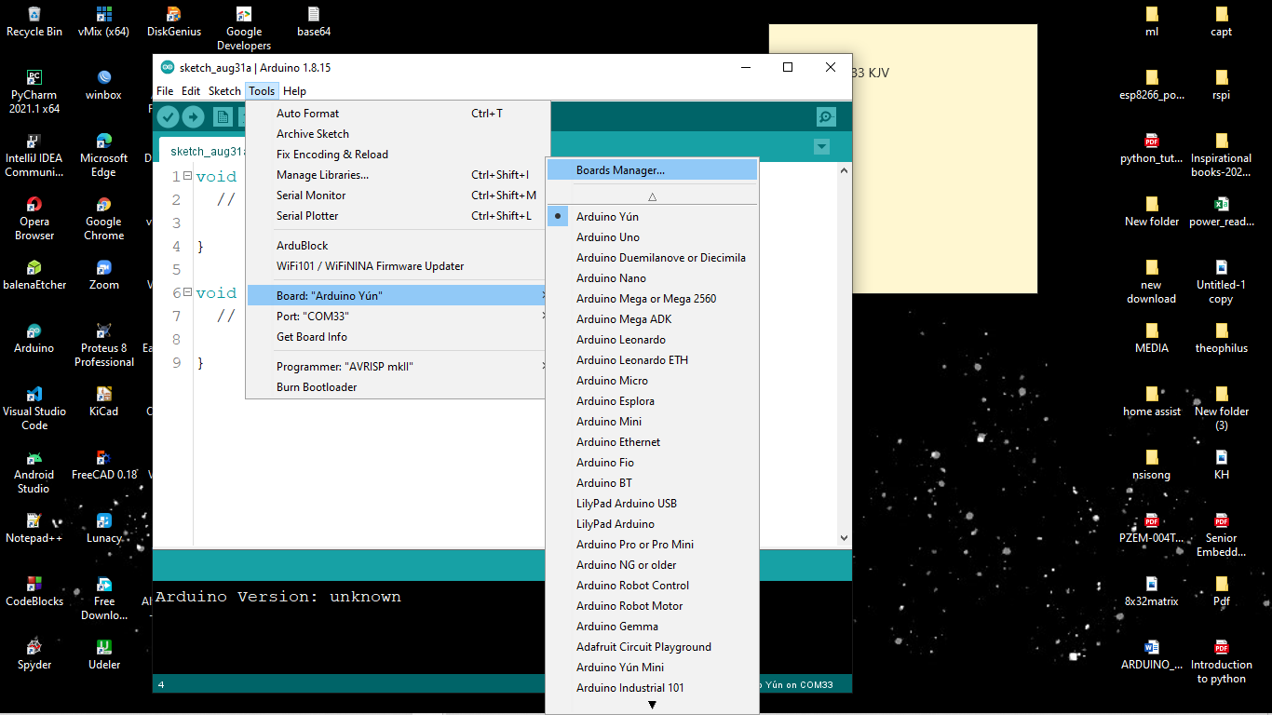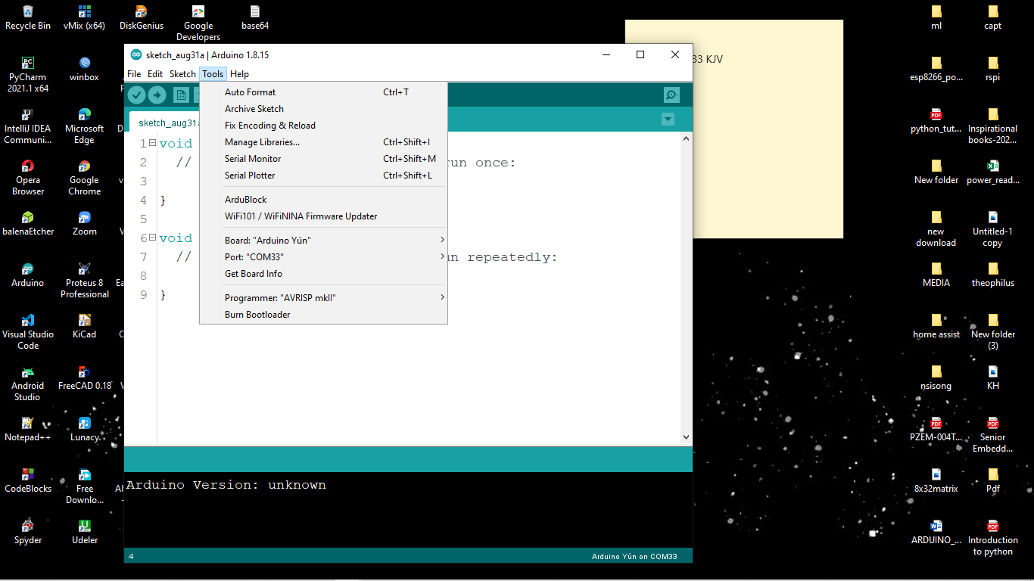From Tools> Board menu> Boards Manager. open Boards Manager and type *esp8266* and click on install. Note, the version may be different at the time you are seeing this. platform
* Select NodeMCU 1.0 (ESO-12E Module) from the Tools> Board menu.

**Using Bitbucket**

If you are reading this, it means that you have been given access to Kodehauz bitbucket.

Navigate to kodehauzteam/sensor_device and clone the repository.

For how to use bitbucket, contact the Embedded systems team lead.

**Running the code**

* After cloning the repo, you should see a folder called “lib” in your local. Copy the content of the folder into your Arduino library folder.
* Open the pmms folder and run the pmms_sensor.ino
* Set your board to nodeMCU 1.0 and set your port to your corresponding esp port.
* Verify and run the code.

**Using the device**

* 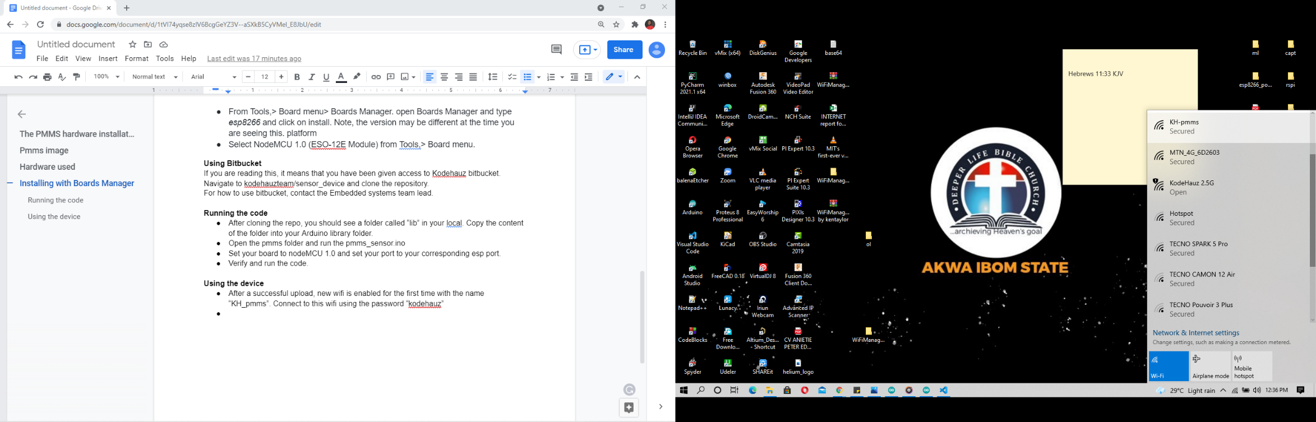After a successful upload, new wifi is enabled for the first time with the name “KH_pmms”. Connect to this wifi using the password “kodehauz”
* 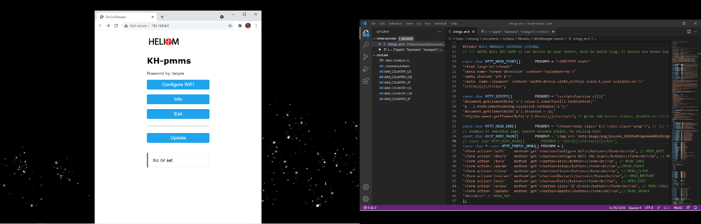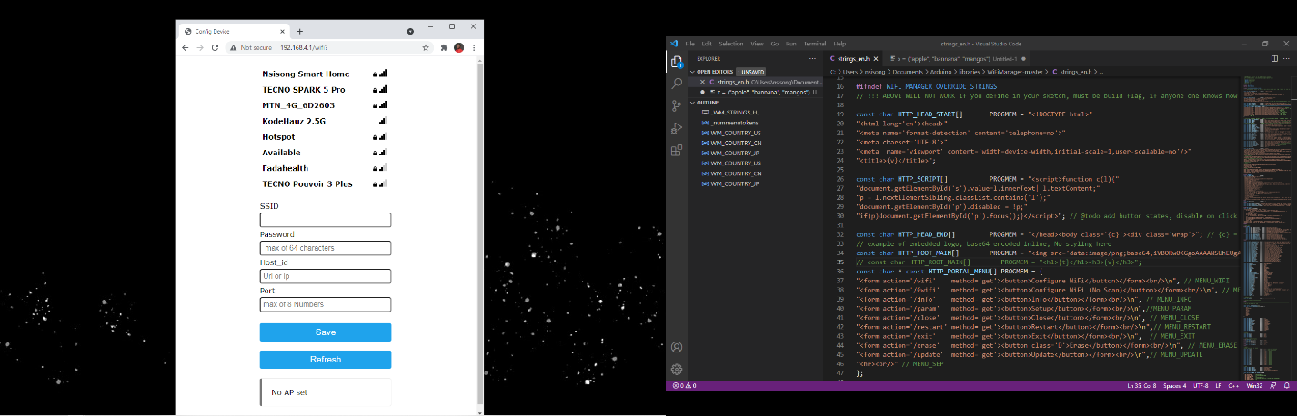Click on “Configure WiFi” to add a wifi network it should connect to.  
  Input the following parameters
  + **SSID** => the new of the network to be connected to or select from the list of the available network displayed
  + **Password** => input the correct password of the selected wifi. Note that password is case sensitive and should not be more than 64 characters
  + **Host_id** => this is the URL or the IP address of the server you want to connect to
  + **Port** => the communication port must be the same as the server.
* Then click on save.
* After the above steps are completed, the captive portal will auto exit and then connect itself to the new wifi.
* If the new wifi is no longer visible to the device, the KH_pmms wifi will be enabled for new wifi to be added or at any time you want to change the SSID to a different one, press and hold the reset button for 5 sec, then everything will be reset and KH_pmms wifi will now be visible for a new configuration.
* For other menu functions on the web interface, see the documentation or contact the Embedded system Team lead.